**SQL Task 7:** PERFORMING OPERATIONS LIKE ALTER, UPDATE AND DELETE IN VIEW

1. creating a view

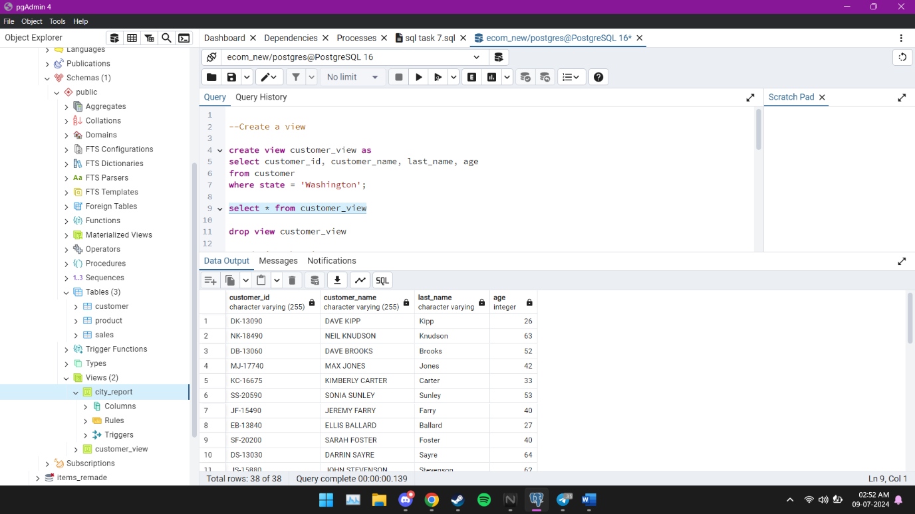

Was able to successfully create a view called “customer_view”

2.updating the view

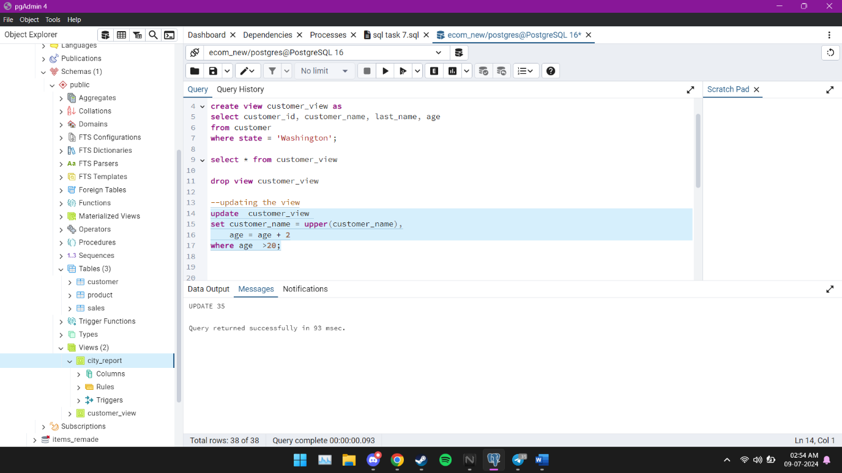

Was able to successfully update the view table to show customer aged less than 20 to be 2 years older in the state of Washington.

3.altering the table

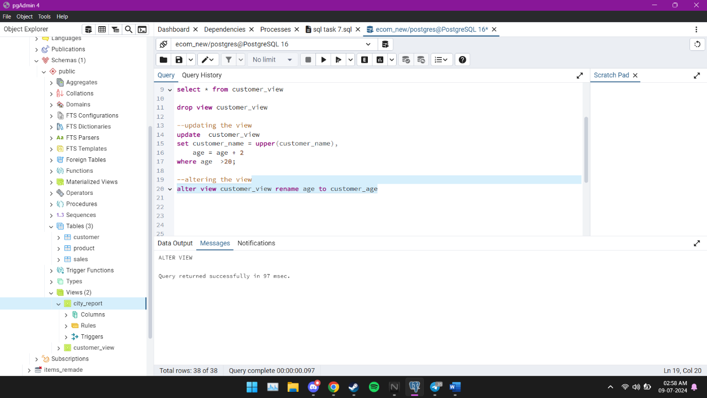

Was unable to perform group by operations or changing column data type but was able to change the column name successfully

4.deleting the view table

Was able to successfully delete entries from the temporary table “customer_view2” that had the age below or equal to 60.

Was able to delete the entire table “customer_view2”

